One page (A4)
Title (~14 point; 抄録は日本語でも可)・・・・

Taro Authora¹, Jiro Authorb^{1,2},,,,, (~10 point; spacing, 12~15 point)
¹Institute A, A University, A City, Japan, ²Center B, B University, B City, Japan, ³C,,,

Introduction (purpose, background as you like) (~10 point; spacing, ~12 point):

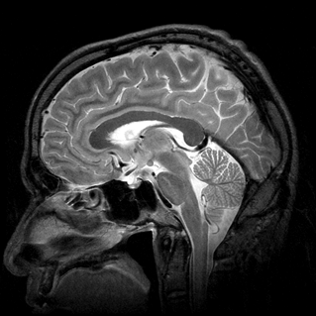
Abc, Abc, Abc

Methods:

Results (or Results and Discussion):

Figure 1 (if necessary). ******. (Color figures are acceptable. Characters in the figures should be clear.)

Discussion (or Results and Discussion):

Figure 2 (if necessary). ******.

Acknowledgement (if necessary):

Conflict of interest (if necessary):

References (if necessary): 1) ***, et al. MRM 2008; 60: ***-***. 2) *****.

--------------------------------------------------------------------------------------------------------------------------------------------
*Abstract submission: attachment of e-mail to ismrmjpc@ifrec.osaka-u.ac.jp
*File: PDF (MS-Word is acceptable.)
*File size: less than 10MB

*Inquiries: ymori@ifrec.osaka-u.ac.jp (Secretary of the meeting)

